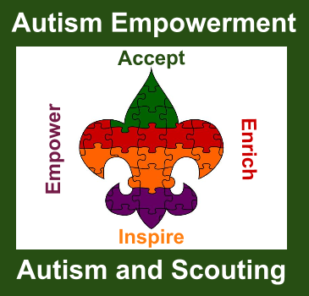
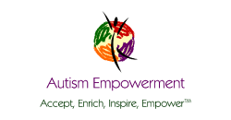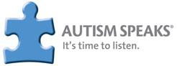

Autism Empowerment Autism and Scouting
Leadership Training Kit Pre-Order Form

Thank you so much for your interest in receiving a copy of Autism Empowerment’s Autism and Scouting Leadership Training Kit. We are a 501(c)3 non-profit organization based in Vancouver, WA that serves the autism & Asperger communities worldwide. Funding for the first 500 Leadership Training Kits was provided by an Autism Speaks Family Community Grant.

This is a two page order form. Please make sure your signature is provided on the final page. Date _____________

_____________________________________ __________________________________________
Unit Name/Number Type of Unit

______________________________________ _________________________________________
Unit Leader / Position Person requesting Kit / Position

_____________________________________ ___________________ ____ _________
Unit Address / Meeting Place City State Zip Code

______________________________________ ____________________ _____ _________
Address of person requesting Kit City State Zip Code

______________________________________ _________________________________________
e-mail where we can confirm address Unit Contact Phone Number (for listing on website)

______________________________________ __________________________________________
Unit Website Address Unit Facebook Address

____________________________________________________________________________________
Other Social Media

Page 2
Unit Name / Number: _________________________________

Other Unit Information you would like to share: _______________________________________________

_____________________________________________________________________________________

By agreeing to receive an Autism Empowerment Autism and Scouting Leadership Training Kit, your unit will be listed on the Autism Empowerment website as a unit that has received this Leadership Training Kit and is open to working with youth who are on the autism spectrum. Your unit is also open to promoting Acceptance of All Abilities.

By agreeing to receive the Autism and Scouting Leadership Training Kit, you agree to be open to taking part in follow-up studies, follow-up contact and/or feedback surveys.

__________________________________________________________ _______________
Requesting Unit Leader Signature Date

What is the Autism and Scouting Leadership Training Kit? The Autism and Scouting Leadership Training Kit is designed to help you and other leaders work positively and more effectively with scouts who are on the autism spectrum.

Who can receive an Autism and Scouting Leadership Training Kit? Through a generous grant from Autism Speaks, Autism Empowerment received funds to be able to develop and produce 500 kits that will be sent to units throughout the United States. Any scouting unit can request a kit. It doesn’t matter if you are a part of the Girl Scouts, Boy Scouts, Cub Scouts, Sea Scouts, American Heritage Girls, Baden Powell Service Association, Campfire USA, Royal Rangers, any faith based scouting organization or any other youth-development organization not mentioned above.

What does the Autism and Scouting Kit consist of? It comes with an Autism and Scouting binder and training manual. It also includes a DVD with training you can use for your full unit and special bonus materials.

Who in the organization can request a kit for the scouting group? We request that a member of scouting leadership make the request. There is only one free kit allotted per unit. (Additional kits can be purchased for $49.95 incl. S/H within the USA. Contact us for international shipping rates.)

What is the cost of the kit? The cost is Free including USPS Media mail shipping in the USA. The USPS does not guarantee delivery of Media mail. If you would like to upgrade shipping to USPS Priority/Insured shipping, the cost is $15.00.

If I order a kit, is my unit guaranteed to be shipped one? The grant that Autism Empowerment received was for 500 kits and the kits have to be sent within the United States.* Each state is allocated a percentage of the kits based on US population. If the state that you reside in has received its full allocation, then no more FREE kits for that state will be available You will be notified via e-mail with the option to purchase a kit at $49.95 incl. S/H within the USA.

*We are seeking additional funding. When additional funding comes available, we will make note at our website.

Autism Empowerment and the Autism and Scouting Program are not affiliated with any scouting organization.. By agreeing to the terms, your unit will be listed as a unit that has made a commitment to comply with each statement. The listing is for information purposes only and not to be used as an endorsement of the unit or its leaders. We reserve the right to remove any listings if we receive complaints or non-compliance with the stated commitments.

Please e-mail this to scouting@autismempowerment.org - 360-852-8369
www.autismandscouting.org - www.autismempowerment.org

