Den Meeting Schedule
Wednesday, November 7th
Opening Flag 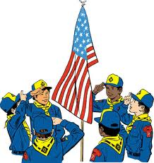 5 Minutes
Station 1 Sewing 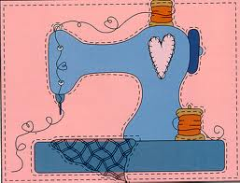 15 Minutes
Station 2 Card Making 15 Minutes
Station 3 Games 15 Minutes
Awards 5 Minutes
Circle time 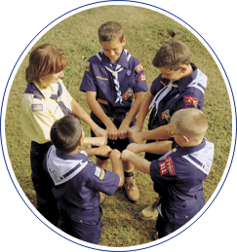 5 Minutes

